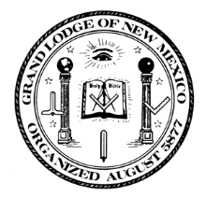 | 140th Annual Communication  Grand Lodge of New Mexico AF & AM  March 16-18, 2017  Albuquerque, New Mexico | 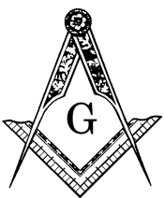

Meeting to be held at:
UNM Continuing Education Complex
1634 University Blvd., NE
Albuquerque, New Mexico

Brethren,

On behalf of the Most Worshipful Grand Lodge of Ancient Free and Accepted Masons of New Mexico, I invite you to attend the 140th Annual Communication, to be held on March 16-18, 2017 in Albuquerque, New Mexico. The business meeting will be held at the UNM Continuing Education Complex next to the Grand Lodge office at 1634 University Blvd, NE. Please see the attached registration form and schedule of events for complete details on meals, programs, and ladies activities.

Lodging accommodations have been arranged with the Marriott Hotel located at 2101 Louisiana Blvd, NE. Direct telephone number is (505) 881-6800. You must identify yourself as being with the Grand Lodge of New Mexico Conference to obtain the special rate. Make room reservation as soon as possible as the block of rooms is limited.

The active participation of all lodges in this Grand Jurisdiction is essential in determining future program needs and direction and is partial fulfillment of the obligation you took as a Master Mason and as an officer of your lodge.

We have planned events full of good food, fun entertainment, and wish all to join us and share in this enjoyable time of Masonic Fellowship. Please review the agenda carefully as we will be traveling throughout Albuquerque for various functions. Business meetings are at the UNM Continuing Education Complex with meals available during the day. The Grand Master’s Reception on Thursday will be at the Ballut Abyad Shrine Center and the Grand Master’s Banquet on Friday will be at the Marriott Hotel. Ladies activities will be headquartered at the Marriott Hotel.

In order to arrange for your comfort and enjoyment, please return your registration form and make your housing reservations as soon as possible.

We look forward to welcoming and visiting with you at our Annual Grand Lodge Communication.

Sincerely and fraternally,

Dennis D. Anderson
Grand Master of Masons in New Mexico

