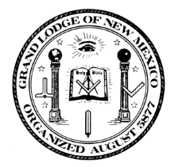 | 140th Annual Communication  Grand Lodge of New Mexico AF & AM  March 16-18, 2017  Albuquerque, New Mexico | 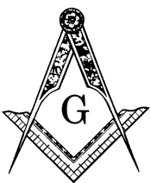

Ladies Invitation
140t^{h} Annual Communication of the Grand Lodge of New Mexico
March 16 – 18, 2017

Dear Friends,

In anticipation of the 140th Annual Communication of the Grand Lodge of New Mexico in Albuquerque, New Mexico, Dennis and I would like to thank you for many wonderful experiences, learning opportunities, and new friendships. To this end, we have been planning events with you in mind, hoping you will enjoy them in the company of Masonic friends.

The ladies schedule of events is as follows:

Thursday, Grand Master’s Reception (No host cocktails & hors d’oeuvres)
March 16, 2017 Ballut Abyad Shrine Center 6600 Zuni Road, SE
6:00 pm – 9:00 pm
Attire: Casual

Friday, Ladies Program and Luncheon
March 17, 2017 El Pinto Restaurant & Cantina, 10500 4th Street, NW
11:00 am – 1:00 pm
Attire: Casual

Enjoy the atmosphere of an old Mexican hacienda with numerous patios and Northern New Mexican cuisine. Located in the old Bosque area of the north valley of Albuquerque you will park underneath century old cottonwoods and dine within majestic old adobe walls, vegas supported ceilings and kiva fireplaces of an old Patron mansion from years ago. The food, the excellent margaritas and the friendly atmosphere is known for its magic of forging friendships for life.

Albuquerque has many wonderful places to explore and shop. We are fortunate to have the Marriot Hotel Shuttle to accommodate your needs. Old Town, with buildings and shops dating to the turn of the century, is a great place to start. Coronado Mall is three blocks north on Louisiana Boulevard. We hope you will partake and enjoy all the Duke City has to offer.

Friday, Grand Master’s Banquet
March 17, 2017 Albuquerque Marriott Hotel (Salon E) 2101 Louisiana Blvd. NE
6:30 pm – 7:30 pm Social Meet and Greet (No Host Bar)
7:30 pm – 11:00 Banquet
Attire: Evening wear or cocktail dress

We would like to offer the centerpieces used for the Grand Master’s Banquet for $20.00 each, proceeds will be divided among the Masonic Youth Groups in New Mexico. Thank you in advance for helping our young people work toward their goals.
Saturday, Memorial Service
March 18, 2017 Grand Lodge of New Mexico 1638 University Blvd. NE
8:00 am
Attire: Business casual

Looking forward to seeing everyone on March 16 - 18. We appreciate your attendance, participation, and especially your support.

Barbara Anderson
(575) 894-3914 or (575) 894-3453

